Project Design Phase-II
Technology Stack (Architecture & Stack)
Date | 14 July 2026
Team ID | Geeta Rani
Project Name | ShopEZ
Maximum Marks | 4 Marks

Technical Architecture:
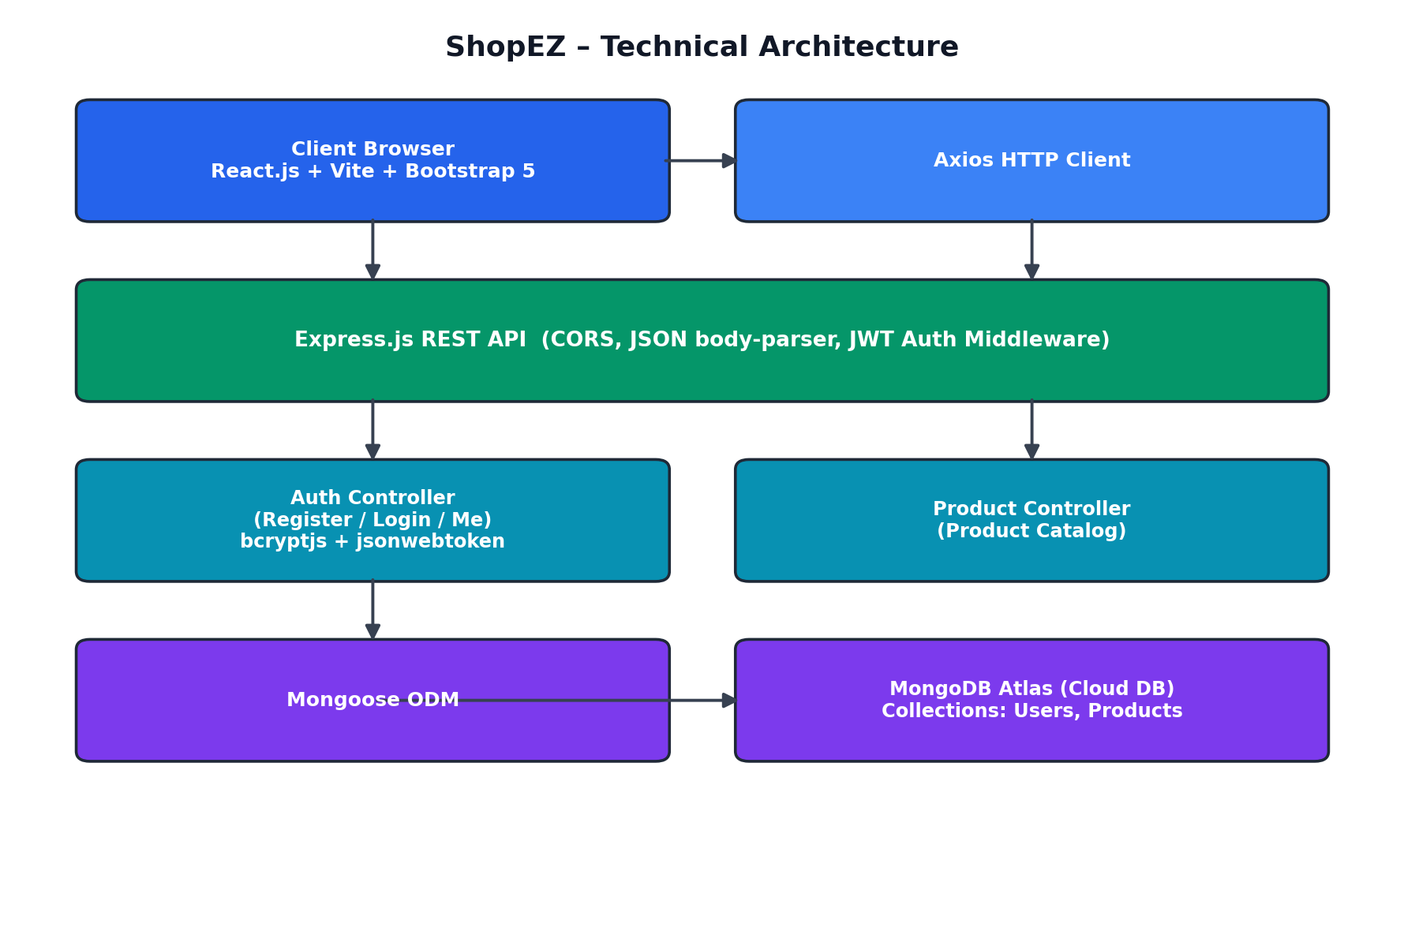

Table-1 : Components & Technologies:
S.No | Component | Description | Technology
1. | User Interface | Product browsing, cart and auth screens | React.js, HTML5, CSS3, Bootstrap 5
2. | Application Logic-1 | Authentication and Authorization | Node.js, Express.js
3. | Application Logic-2 | Product Catalog Retrieval | Node.js, Express.js
4. | Application Logic-3 | Cart & Currency Management | React Context (Client-side)
5. | Database | Store users and account data | MongoDB
6. | Cloud Database | Cloud-hosted database service | MongoDB Atlas
7. | File Storage | Product image hosting | External Image CDN (Picsum)
8. | External API-1 | REST API communication between frontend and backend | Axios
9. | External API-2 | Authentication Token Verification | JWT (JSON Web Token)
10. | Machine Learning Model | Not Applicable | N/A
11. | Infrastructure (Server / Cloud) | Frontend and Backend deployment environment | Local System / Node Server, MongoDB Atlas Cloud

Table-2: Application Characteristics:
S.No | Characteristics | Description | Technology
1. | Open-Source Frameworks | Frameworks used for application development | React.js, Node.js, Express.js, MongoDB
2. | Security Implementations | Authentication, Authorization and Password Protection | JWT Authentication, bcrypt Password Hashing
3. | Scalable Architecture | Three-tier architecture with separate frontend, backend and database layers | MERN Stack Architecture
4. | Availability | Users can access services anytime through a web application | React + Node.js + MongoDB Atlas
5. | Performance | Fast product browsing, login and cart updates with optimized API calls | Axios, Express.js, MongoDB Indexing

